**Monsanto**

14

**Cyto-Engine v 1.2**

**User Guide**

**Sandeep Laik**

What is Cyto-Engine?

Cyto-Engine is a tool/executable that converts the regular excel data to Cytoscape compatible ( .xgmml) format for data visualization.

This tool is customized for collaboration specific data however we can apply the same logic and build tools for other data as well.

At this point this tool has been tested with Cytoscape 2.8.3, but it should be able to support all the similar releases of Cytoscape.

Walkthrough: -

1. Double click and launch “Cyto-Engine V 1.2.exe”
2. Locate and select the excel file with all the collaboration data.

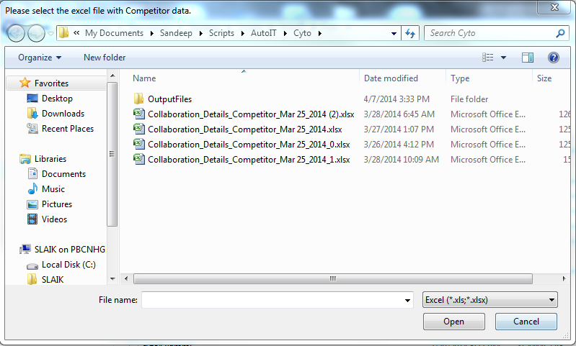

**The file should not contain any data with special Unicode character such as ©, ® , ™ ,ᾏ etc as Cytoscape Import functionality doesn’t support these characters.

1. After selecting the file in the next popup enter the company name for which we are trying to create the network and click OK.

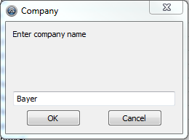

1. In the next popup select the year and click OK. Data will be picked which belongs to this year or later.

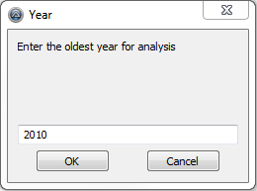

1. After this screen script will take some processing time (typically between 15 to 30 sec depending on system configurations). Once the processing completes successfully script will return a popup with output folder/file information.

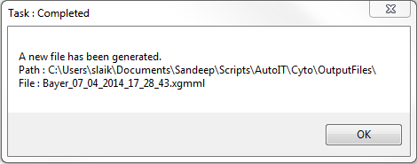

**The output of this script is usually stored in a folder named OutputFiles (this folder gets created automatically if doesn’t exist) which resides in the same folder as the script.

1. Now we need to launch Cytoscape window.

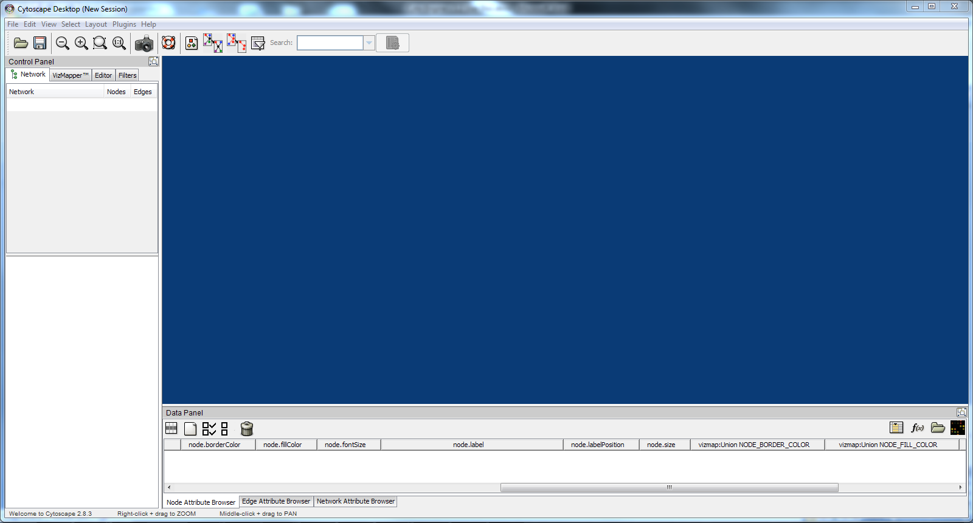

1. Now we can open the import file popup by either pressing Ctrl + L or by navigating through File -> Import -> Network(Multiple File Types)…

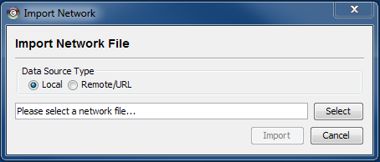

1. Click select and browse to the new .xgmml file that was created by the script, now select and open the file and click Import in the import network popup.(The file must be inside the OutputFiles folder.)

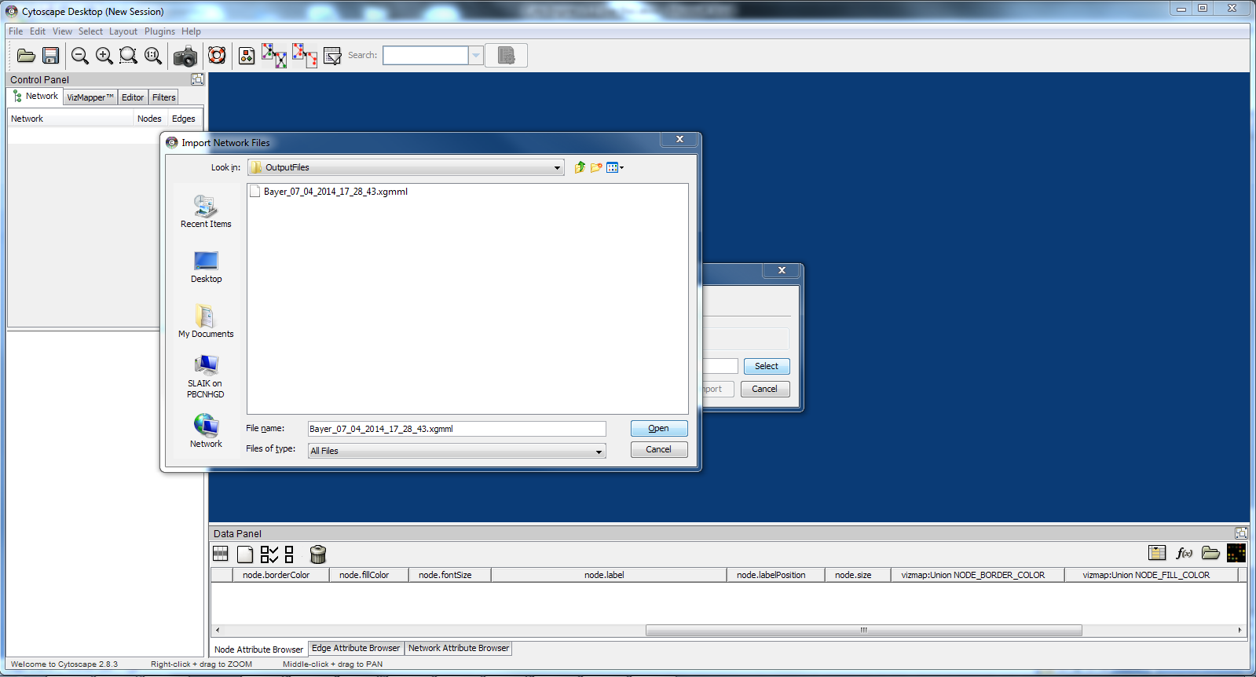

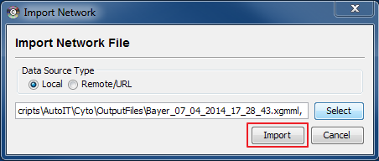

1. Wait for the file to get uploaded. There can be 2 outcome of this action. If the file has any issue it will fail to import, and in that case please get back to us and we will look into it. But in case of successful import you will receive a success popup. Click close to close the popup.

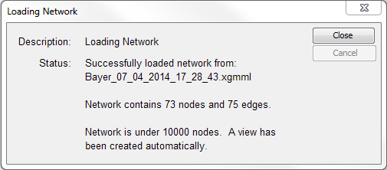

1. Click on Apply force detect layout to let the network re-order itself automatically.

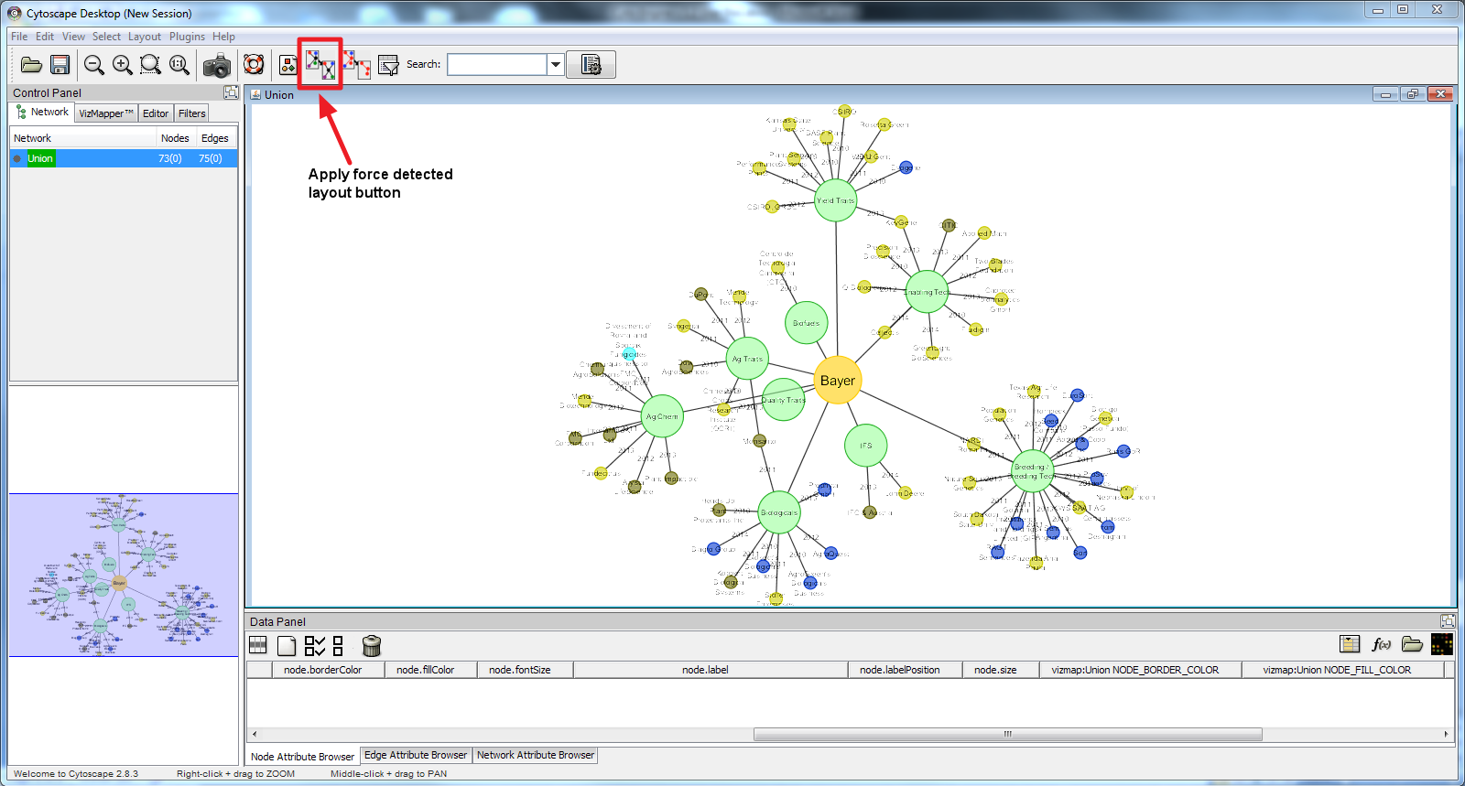

1. **The network is complete on it’s own at this point, however you may wish to see the data for the smaller nodes next to the node instead of overlapping it. The below mentioned steps will help you with that.**
2. Go to the filter tab at the left top of the Cytoscape screen. Select the filter definition or property as node.node.size and under advanced select the size value as 25.0.

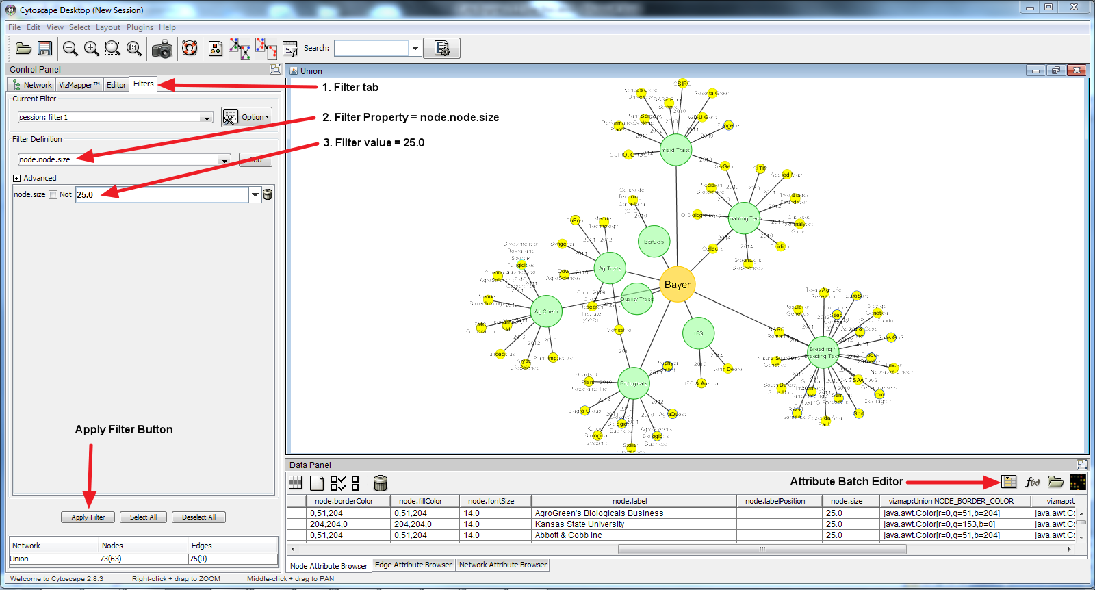

1. All the small nodes with the size 25 should get auto selected on the screen and all of them should change the color to yellow as shown in the screenshot. If not then please click on Apply filter button.
2. Once all the preferred node is selected click on the Attribute Batch Editor button at the right bottom of the screen.(as shown in the previous screenshot)
3. An attribute popup should show up.

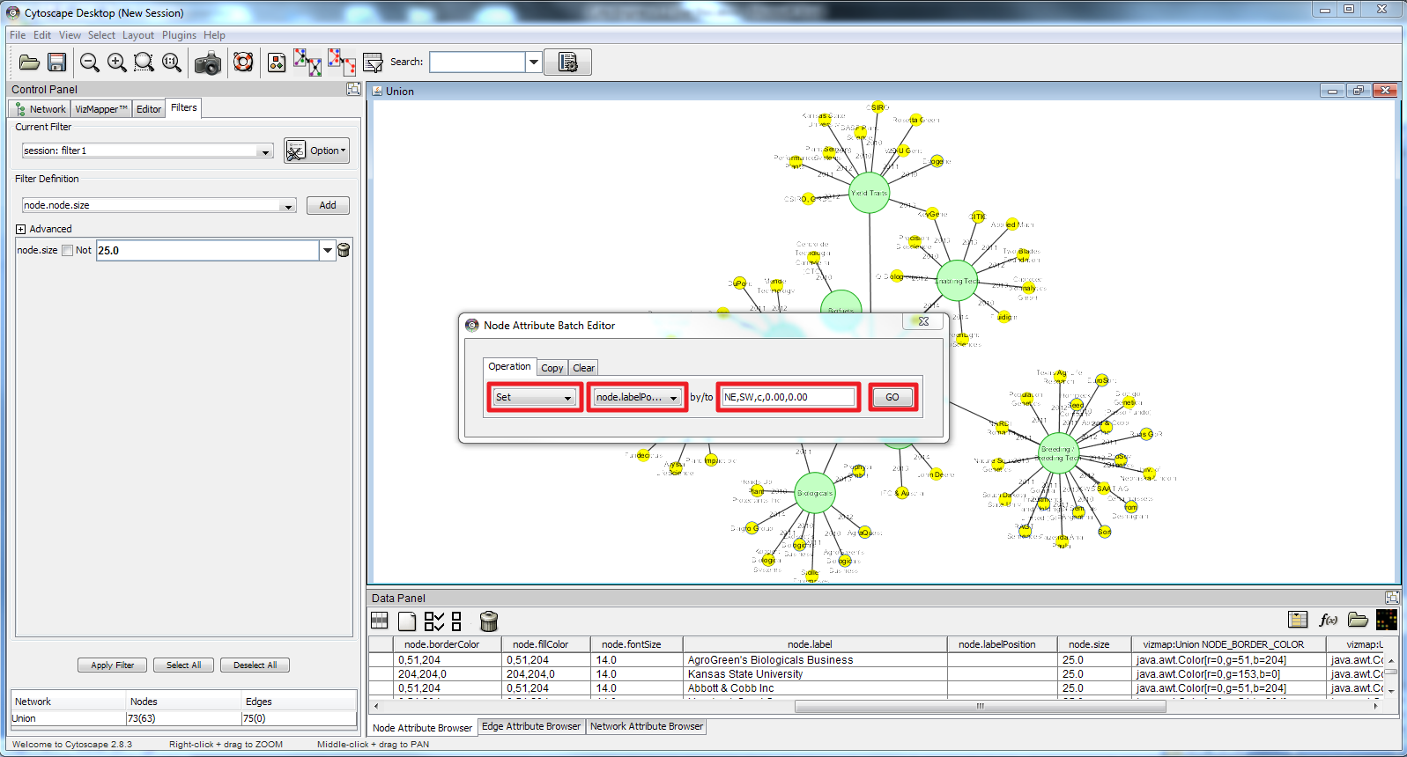

1. In the Node Attribute Batch Editor popup(as shown in the screenshot above) in the Operation tab select the values as Set -> node.labelPosition -> NE,SW,c,0.00,0.00 and click on the GO button.
2. This will shift all the labels for the selected nodes to the right top corner of the respective node. This way you will be able to see the node without overlapping with the labels.

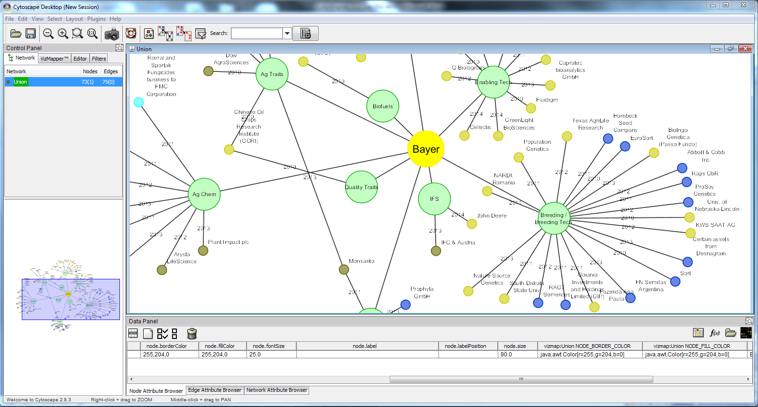

For any further info reach out to:

***Sandeep Kumar Laik.***

***TPS India- Automation Test Engineer.***

cid:image001.png@01CD1339.A0131080

cid:image002.png@01CD1339.A0131080

Monsanto Holdings Pvt. Ltd.,  Manyata Embassy Business Park I Bangalore I INDIA

Ph: (Cell) +91-99-16901970 I e-mail: [sandeep.kumar.laik@monsanto.com](mailto:sandeep.kumar.laik@monsanto.com) I URL:  [www.monsanto.com](http://www.monsanto.com/)

"...because, It's just about never being satisfied with your past performances..." :)